Experiment No. 10

CampusLedger: A Blockchain-Based Student Attendance Management System
Submitted in partial fulfillment of the requirements of
Mini Project
in
B.E. (Artificial Intelligence and Data Science)
By
Name | Roll Number
Sumit Patil | 05
Vedant Patil | 07
Akshat Puthran | 14
Swarup Salavkar | 17
Supervisor:
Prof. Shubhangi Katke

Department of Artificial Intelligence and Data Science
DATTA MEGHE COLLEGE OF ENGINEERING, AIROLI,
NAVI MUMBAI - 400 708.

University of Mumbai
(A.Y. 2026-27)
CERTIFICATE
This is to certify that the mini project entitled “CampusLedger: A Blockchain-Based Student Attendance Management System” has been carried out by Sumit Patil (05), Vedant Patil (07), and Akshat Puthran (14) under the guidance of Prof. Shubhangi Katke, in partial fulfilment of the requirements for the degree of Bachelor of Engineering in Artificial Intelligence and Data Science, University of Mumbai, during the academic year 2026–27.
The work presented in this report is an original record of the work carried out by the students and has not been submitted elsewhere for any other degree or diploma.
Prof. Shubhangi Katke
Project Guide

ABSTRACT
Attendance in most colleges is still recorded in paper registers or in a central database that a single custodian controls. Such records are easy to edit after the fact, and the edit is difficult for anyone else to notice. Proxy attendance, retrospective corrections, and disputes over who changed what are common consequences, and the institution has no cryptographic evidence to settle them.
To address this problem, this project, CampusLedger, implements a working web application for managing student attendance on a blockchain-style ledger. A teacher signs in, selects the class date, subject, and faculty name, and marks each student on the roster as Present or Absent. Every individual mark is recorded as its own block. Each block carries the SHA-256 hash of the block before it, all the way back to a Genesis block, so changing any past record breaks every link that follows it.
The application provides a teacher dashboard with live totals for students, attendance records, and students present and absent on the day, together with a ledger-integrity indicator. It also provides a records view, a student summary with attendance percentage, class reports, and a blockchain explorer that lets the user inspect every block’s previous hash and current hash and re-validate the whole chain with one click. The result is a tamper-evident, auditable attendance system with a professional college-dashboard interface, which also serves as a hands-on demonstration of how blockchain can protect institutional records.

LIST OF FIGURES
Figure 1: System architecture of CampusLedger
Figure 2: Hash linkage between attendance blocks
Figure 3: CampusLedger home page
Figure 4: Teacher dashboard with ledger integrity status
Figure 5: Mark attendance screen with class roster
Figure 6: Blockchain explorer showing the Genesis block and Block #1
LIST OF TABLES
Table 1: Key terms used in this project
Table 2: Fields stored in each attendance block
Table 3: Application modules and their purpose
Table 4: Sample statistics observed during testing
Table 5: Comparison between conventional attendance systems and CampusLedger

CONTENTS
Abstract
List of Figures
List of Tables
1 Introduction 1
1.1 Introduction 1
1.2 Literature Survey 1
1.3 Problem Statement & Objectives 1
1.4 Technology Stack 2
2 System Design 2
2.1 Framework 2
2.2 Block Structure and Chaining 3
2.3 Software Requirements 5
2.4 Hardware Requirements 5
3 Implementation and Results 5
3.1 System Implementation 5
3.2 Results and Observations 8
3.3 Scope and Limitations 9
3.4 Comparison with Conventional Systems 9
4 Conclusion 9
Future Work 10
References 10

1. INTRODUCTION

1.1 Introduction
Taking attendance is one of the most routine activities in a college, yet the resulting records feed into decisions that matter: eligibility to sit examinations, internal marks, and scholarship or compliance reporting. Traditionally these records are kept in a paper register or in a database managed by one person or office. Whoever holds the record can change it, and nobody else can prove that it was, or was not, changed.
A blockchain is a list of records, called blocks, that are linked together using cryptographic hashes so that altering any past record is immediately detectable. Public interest has largely centred on cryptocurrencies, but the underlying idea is far more general: it is a way of keeping an append-only record whose history cannot be silently rewritten.
CampusLedger applies that idea to student attendance. It is a web application, run locally in the browser at 127.0.0.1:5000, in which a teacher marks each student Present or Absent and every individual mark becomes a block in a SHA-256 hash-linked ledger, starting from a Genesis block. The application then lets the teacher review records, compute attendance percentages, generate reports, and open a blockchain explorer to inspect each block and validate the whole chain. The interface is designed to look and behave like a professional college management dashboard rather than a technical demonstration.

1.2 Literature Survey
The concept of a cryptographically linked chain of records was popularised by Nakamoto’s Bitcoin whitepaper, which combined hashing, chaining, and proof-of-work into a peer-to-peer electronic cash system secured by computational cost rather than by a trusted third party [1]. The same hashing-and-chaining foundation has since been reused far beyond cryptocurrency: Ethereum introduced programmable smart contracts written in Solidity [2], and permissioned enterprise frameworks such as Hyperledger Fabric target organisations that need shared, auditable records among known participants [3].
In education, blockchain has mostly been explored for issuing and verifying certificates and academic credentials. Attendance management has received less attention, even though it has the same requirements: records are created frequently, must not be altered retrospectively, and must be checkable by several parties (students, teachers, and administrators). Existing attendance software is generally a conventional database application with a login screen, which protects access but does not make later modification detectable.
This project sits between a purely theoretical treatment of blockchain and a full decentralised application. Unlike an explainer, it is a complete, usable attendance system with real workflows (roster, marking, records, summaries, reports). Unlike a full dApp built with wallets and gas fees, it keeps the ledger local so that the core idea, tamper-evident attendance records, can be demonstrated on a single computer, with the migration to a smart-contract platform identified as future work.

1.3 Problem Statement & Objectives
Attendance records in conventional systems can be modified after the fact without leaving evidence, and there is no independent way to verify that a stored record is the one originally entered. There is a need for a practical attendance management system in which every mark is permanently linked to the history before it, so that any alteration is detectable and the integrity of the whole record can be verified on demand.
Objectives:
- To build a web application in which a teacher can sign in, maintain a class roster, and mark each student Present or Absent for a given date, subject, and faculty.
- To record every individual attendance mark as a separate block linked to the previous block through a SHA-256 hash, starting from a Genesis block.
- To provide a dashboard that summarises the total students, attendance records, and students present and absent today, along with a live ledger-integrity status.
- To provide records, student summary, and report views that filter attendance, calculate attendance percentage, and show class history.
- To provide a blockchain explorer that displays each block’s details and hashes and can re-validate the entire chain on demand.
- To present all of the above in a clean, professional, college-dashboard style interface suitable for real classroom use.

1.4 Technology Stack
CampusLedger is built as a lightweight web application that runs on the user’s own machine. No external blockchain network, cloud service, or wallet is required for the version presented in this report.
Markup & Styling | HTML5 and CSS3 with a custom, responsive design system: card-based dashboard layout, consistent navigation bar, status badges, and a blue and white college theme.
Client-side Logic | JavaScript for interactive elements such as the Present / Absent toggles, the date picker, and the Validate blockchain action.
Server Side | A lightweight Python web application served locally on 127.0.0.1:5000, handling teacher authentication, routing, form validation, and reports.
Cryptography | SHA-256 (Secure Hash Algorithm, FIPS 180-4) used to compute the hash of every block.
Ledger Storage | An append-only chain of block records, beginning with a Genesis block; each attendance mark adds one block.
Runtime | Any modern desktop browser (Chrome, Edge, Firefox) to view the interface; the server runs on a standard laptop.

2. SYSTEM DESIGN

2.1 Framework
CampusLedger follows a five-stage pipeline that repeats every time attendance is taken. First, the teacher signs in and opens the Mark attendance page. Second, the teacher enters the session details (date, subject, faculty name) and selects Present or Absent for each student on the roster. Third, for each mark the blockchain module creates a new block containing the student, status, subject, date, faculty, and timestamp. Fourth, the block is linked by storing the hash of the previous block and computing its own SHA-256 hash, then it is appended to the ledger. Fifth, the dashboard, records, and explorer views read the ledger and report the results, including whether the chain is still valid.
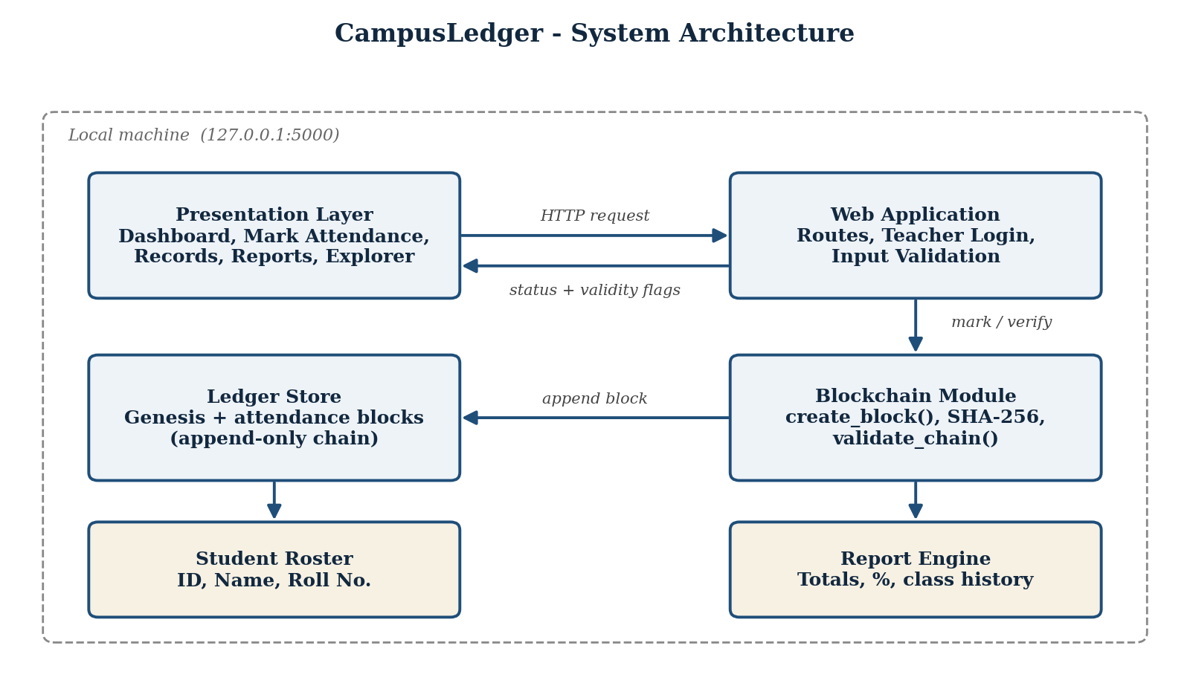
Figure 1: System architecture of CampusLedger
The presentation layer contains the pages the user sees: Dashboard, Students, Mark attendance, Records, Student summary, Explorer, and Reports. The web application handles requests and teacher login. The blockchain module owns block creation, hashing, and chain validation, and is the only component that writes to the ledger. A separate student roster and a report engine supply the names, IDs, and totals that the interface displays.

2.2 Block Structure and Chaining
Every attendance mark is stored as one block. A block holds the information about the mark together with two hashes: the hash of the previous block (Previous Hash) and its own hash (Current Hash), which is computed over all of its contents including the previous hash. Because each hash depends on the one before it, each block indirectly depends on the entire history that came earlier. The Genesis block is a special case: it has no real predecessor, so its previous hash is set to sixty-four zeros.
Table 2: Fields stored in each attendance block
Field | Description
Block number | Position of the block in the chain (Genesis is the origin; attendance blocks are numbered #1, #2, and so on).
Student name and ID | The student to whom the mark applies (for example, Rahul Patil, ID 101).
Status | Present or Absent, shown as a coloured badge in the explorer.
Subject | The subject or class for which attendance is taken.
Date | The date of the class session.
Faculty | The name of the faculty member who took the attendance.
Timestamp | The exact date and time at which the block was created (ISO 8601, UTC).
Previous hash | The SHA-256 hash of the preceding block (all zeros for the Genesis block).
Current hash | The SHA-256 hash of this block’s own contents, including the previous hash.

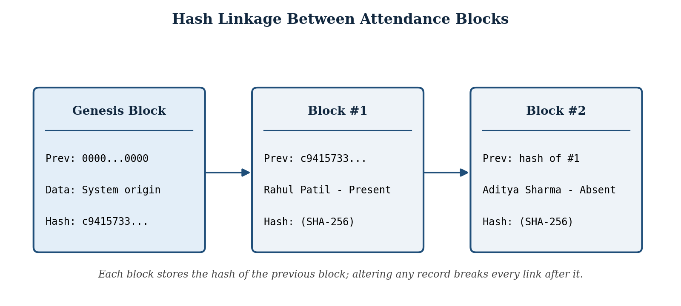
Figure 2: Hash linkage between attendance blocks
If someone alters a past record, for example changing an Absent mark to Present, the recomputed hash of that block no longer matches the hash stored on it, and the next block’s stored previous hash no longer matches either. The validation routine detects this immediately, and the dashboard indicator changes from “Blockchain valid” to an invalid state.
Table 1: Key terms used in this project
Term | Meaning
Hash | A fixed-length, 64-character hexadecimal fingerprint of data produced by SHA-256. Any change to the input completely changes the output.
Block | One unit of the ledger. In CampusLedger, one block holds one student’s attendance mark.
Genesis block | The first block of the chain, which has no real predecessor and uses a previous hash of all zeros.
Append-only ledger | A record to which new entries can be added but existing entries cannot be silently changed.
Tamper-evidence | The property that altering recorded data leaves a detectable trace, rather than preventing alteration outright.
Chain validation | Recomputing every block’s hash and checking every link to confirm that the whole ledger is consistent.

2.3 Software Requirements
Browser | Any modern browser such as Google Chrome, Microsoft Edge, or Mozilla Firefox.
Server Runtime | A Python environment capable of running the local web application on port 5000.
Editor / IDE | Any text editor or IDE used during development, for example VS Code (not required to run the finished application).
Operating System | Windows, macOS, or Linux.

2.4 Hardware Requirements
Processor | Any standard modern processor; hashing one block is computationally trivial.
Memory | Minimal; 4 GB of RAM is more than sufficient for the application and a browser.
Storage | Small; the application and ledger occupy only a few megabytes.
Network | None required for normal operation; the application runs entirely on the local machine.

3. IMPLEMENTATION AND RESULTS

3.1 System Implementation
The implementation is organised around a small number of pages, each serving one task in the attendance workflow, all backed by the same hash-linked ledger. Each is described below with the corresponding screenshot of the running application.
Table 3: Application modules and their purpose
Module | Purpose
Dashboard | Overview of totals, today’s present and absent counts, and ledger integrity.
Students | Add or remove students from the class roster.
Mark attendance | Enter session details and mark each student Present or Absent.
Records | Filter and inspect individual attendance submissions.
Student summary | Per-student attendance totals and attendance percentage.
Explorer | Inspect every block and validate the blockchain.
Reports | Attendance totals and class history.

3.1.1 Home Page and Teacher Login
The landing page introduces the system as a “Blockchain-Based Student Attendance Management System” offering secure and tamper-evident attendance management. It provides Teacher Login and Mark Attendance buttons, quick links to View attendance and the Blockchain explorer, and a Live Ledger preview card that illustrates how a recorded class becomes a hash-verified block linked to the previous one. A three-step summary at the bottom explains the workflow: Record (mark a class roster), Link (hash each attendance block), and Verify (detect any record changes). The top navigation bar gives access to every module.
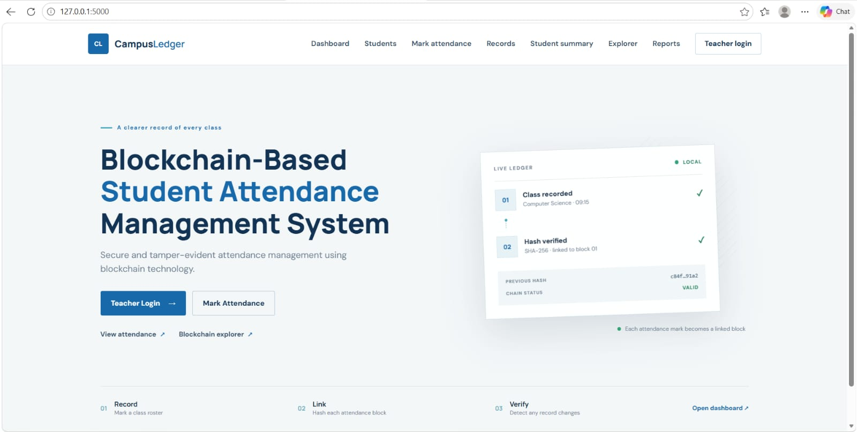
Figure 3: CampusLedger home page

3.1.2 Teacher Dashboard and Ledger Integrity
After signing in, the teacher lands on the dashboard, which presents the day’s activity at a glance. Four summary cards show the total students in the current roster, the number of attendance records (individual marks) recorded, and how many students were marked present and absent on the current date. Below them, a Ledger Integrity panel states “Blockchain valid” with the message that all block hashes and attendance records are consistent, and links to the explorer for inspection. Shortcuts lead to managing students, attendance records, and the attendance report.
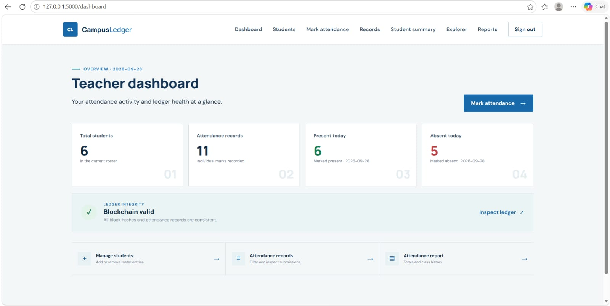
Figure 4: Teacher dashboard with ledger integrity status

3.1.3 Marking Attendance
The Mark attendance page is where blocks are created. The teacher first fills in the Class information: the date (pre-filled with the current date), the subject, and the faculty name. The Class roster then lists each student with a name, a numeric ID, and a roll code, for example Rahul Patil (ID 101, CS001) and Aditya Sharma (ID 102, CS002), together with Present and Absent buttons. The page states that each student’s status is recorded as an individual block in the ledger, so submitting a class of N students appends N new blocks.
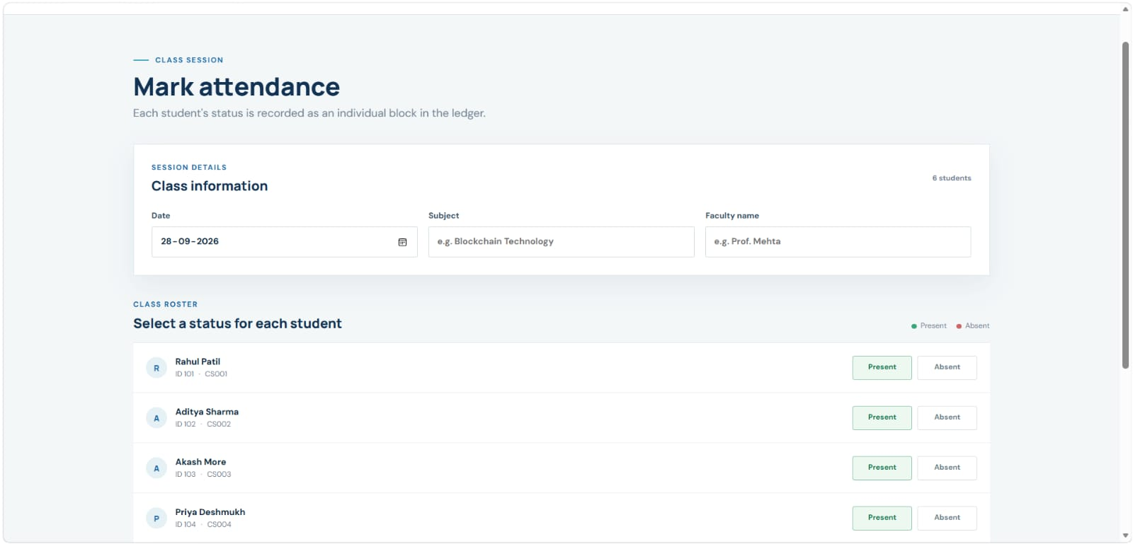
Figure 5: Mark attendance screen with class roster

3.1.4 Records, Student Summary, and Reports
The Records page lets the teacher filter and inspect submissions by student, date, subject, or status. The Student summary page presents each student’s totals and calculates attendance percentage as the number of classes attended divided by the total number of classes held, multiplied by 100. The Reports page provides overall totals and class history, giving the teacher or administrator a printable overview of attendance for the period.

3.1.5 Blockchain Explorer and Validation
The Blockchain explorer is the module that makes the blockchain evident to the user. It is labelled “SHA-256 · Append-only ledger” and shows the number of blocks in the chain (in the test run, 12 blocks: the Genesis block plus 11 attendance records). Each block is displayed as a card containing its subject, date, student ID, faculty, timestamp, and the previous and current hashes, with a downward arrow connecting it to the next block. The first card is the Genesis block, with subject “System origin”, a previous hash of all zeros, and its own current hash. Block #1 records Rahul Patil with a Present badge. A green “Blockchain valid” indicator and a Validate blockchain button allow the entire chain to be re-checked at any time.
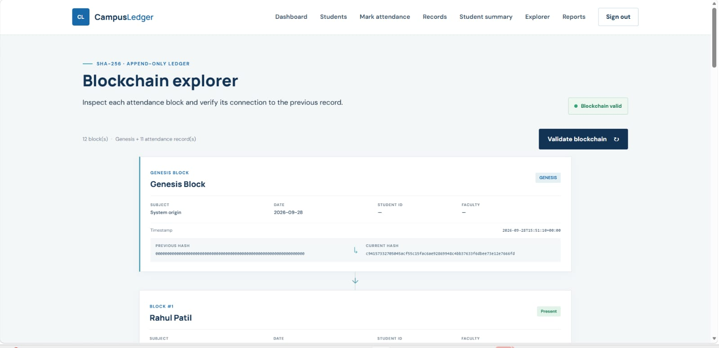
Figure 6: Blockchain explorer showing the Genesis block and Block #1

3.1.6 Tamper Detection
When validation runs, the system walks the chain from the Genesis block onward. For each block it recomputes the SHA-256 hash from the block’s current contents and compares it with the stored current hash, then checks that the block’s stored previous hash equals the current hash of the block before it. If either check fails, the chain is reported as invalid. Because every later block’s hash depends on the earlier one, a single altered record cannot be hidden without recomputing every block that follows it.

3.2 Results and Observations
The application was tested by running it locally, signing in as a teacher, marking attendance for the class roster, and reviewing the results in the dashboard, records, and explorer views. The observations recorded during testing are summarised below.
Table 4: Sample statistics observed during testing
Item | Observed value
Test date | 2026-09-28
Students on roster | 6
Attendance records (individual marks) | 11
Marked present on the test date | 6
Marked absent on the test date | 5
Blocks in the ledger | 12 (Genesis block + 11 attendance blocks)
Genesis block previous hash | 64 zeros
Ledger integrity status | Blockchain valid

The dashboard totals agree with the explorer: 11 attendance records correspond to 11 blocks after the Genesis block, and every block was reported as consistent by the validation check. Each attendance mark is created as its own block, so the ledger grows one block per student per session.

3.3 Scope and Limitations
This version of CampusLedger implements the core of a blockchain, hashing, linking, and validation, inside a single-machine web application. It deliberately does not attempt several things that production blockchain platforms provide:
- A distributed network of independent nodes that must agree on one chain (consensus); the ledger here is held by a single local application.
- Digital signatures or wallet-based identity proving which account authorised each block; teacher identity is established through login.
- Smart-contract execution on a public or private blockchain such as Ethereum; the chain logic lives in the application itself.
- Automatic resolution of competing chains (forks) when several parties write at the same time.
Each of these is a substantial topic in its own right and is identified as future work.

3.4 Comparison with Conventional Systems
Table 5 compares CampusLedger with the paper registers and database-backed attendance software that colleges typically use, and with the smart-contract-based deployment proposed as future work.
Table 5: Comparison between conventional attendance systems and CampusLedger
Aspect | Conventional register / database | CampusLedger (this project) | Smart-contract deployment (future)
Record integrity | Can be edited silently by the custodian. | Hash-linked blocks; edits break the chain. | Immutable once confirmed on-chain.
Tamper detection | Manual audit, if at all. | One-click chain validation. | Automatic through network consensus.
Trust model | Trust the administrator. | Verify the hashes yourself. | No single point of trust.
Setup and cost | Low. | Low; runs on a laptop. | Higher; needs a wallet and network fees or a private chain.
Auditability | Limited. | Explorer shows every block and hash. | Public transaction history.

4. CONCLUSION
CampusLedger demonstrates that blockchain principles can be applied to an everyday college workflow in a practical, usable way. By recording each Present or Absent mark as its own SHA-256-linked block, the system turns attendance from a record that can be quietly edited into one whose history can be verified. The teacher dashboard, records, student summary, reports, and blockchain explorer provide a complete attendance workflow in a professional interface, while the integrity indicator and Validate blockchain control make the tamper-evidence visible to any user. The project achieved its objectives of building a working, tamper-evident attendance management system and provides a solid foundation for migrating the ledger to a smart-contract platform.

FUTURE WORK
- Deploy the attendance ledger as a Solidity smart contract on a development blockchain (Hardhat or Ganache), so that attendance records are written and read on-chain and transaction details can be shown for each mark.
- Integrate wallet-based identity through MetaMask and the ethers.js library so that each teacher action is signed by an account.
- Rebuild the front end with Next.js, React, TypeScript, and Tailwind CSS, keeping only non-blockchain metadata in a lightweight local database.
- Add a student login so that students can view their own attendance and percentage directly.
- Add automatic low-attendance alerts and export of reports to PDF and CSV.
- Explore QR-code or geofenced check-in to reduce proxy attendance at the point of marking.
- Simulate a small peer-to-peer network of nodes to demonstrate consensus and fork resolution.

REFERENCES
[1] S. Nakamoto, “Bitcoin: A Peer-to-Peer Electronic Cash System,” 2008.
[2] G. Wood, “Ethereum: A Secure Decentralised Generalised Transaction Ledger,” Ethereum Project Yellow Paper, 2014.
[3] E. Androulaki et al., “Hyperledger Fabric: A Distributed Operating System for Permissioned Blockchains,” Proceedings of the Thirteenth EuroSys Conference, 2018.
[4] National Institute of Standards and Technology, “Secure Hash Standard (SHS), FIPS PUB 180-4,” U.S. Department of Commerce.
[5] Solidity Documentation, Ethereum Foundation, docs.soliditylang.org.
[6] Hardhat Documentation, Nomic Foundation, hardhat.org.
[7] ethers.js Documentation, docs.ethers.org.

